Shifter Adjustment 1994-up Honda Magna V750 (One Way)

Note: I’ll begin by saying there may be more ways than this to adjust the shifter, but it worked well for me and it’s not rocket science so that helps. I had my bike for two weeks when I decided to do this bit of surgery. However, I did not have the forethought to document it with photos as I now do. If the following explanation is not clear, feel free to call me on my cell 713.828.2455 or my home 281.277.6168……….biff

The Plan:
The adjustment is not in the linkage as it would appear. The adjustment is in the positioning of the lever that physically attaches to the “shift linkage” shaft (Item 4 on the attached PDF labeled “Gearshift Linkage Removal/Installation.” I found no photo or drawing of the actual “shift lever” that attaches to the “shift linkage” shaft but it is obvious sense the other end of the “linkage rod” attaches to the “foot shifter.”

The “shift lever” is a pretty standard design that you’ve probably seen before. I’m sorry that I have no photo or drawing of the part, nor do I have a convenient way to draw a picture of it, but I’ll do my best to describe it. The base is drilled and notched so it slips over the notched shaft of the shift linkage. The base of the drilled and notched opening is split and extends below the notched opening to accommodate a threaded retainer bolt. When the bolt is tightened, the notched opening compresses around the notched shaft and holds it in place.

All you need to do is loosen the retainer bolt, slip the lever off the “shift linkage” shaft rotate it one or two notches, (depends on how fat your foot is) slide it back into place and retighten the bolt. I don’t remember if you rotate the lever clockwise or counterclockwise, but that will become obvious once your there.

The Process: (Uh Oh, I’m seeing a break in the cloud cover. I think it’s time for a ride…be back later.) ….Ahhhh. Yep, the shifter still works.

OK here’s what you want to end up with (this should look higher than yours):
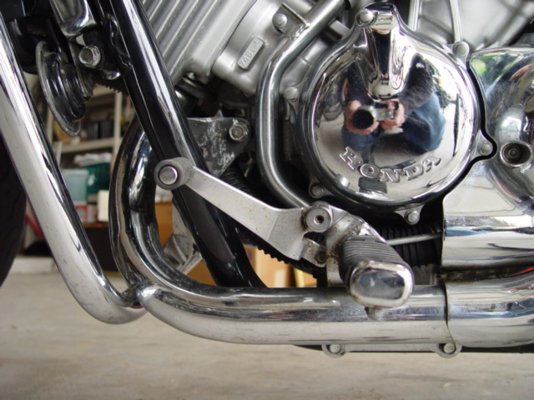

Step 1 Loosen the clutch cable at the adjusting screw:
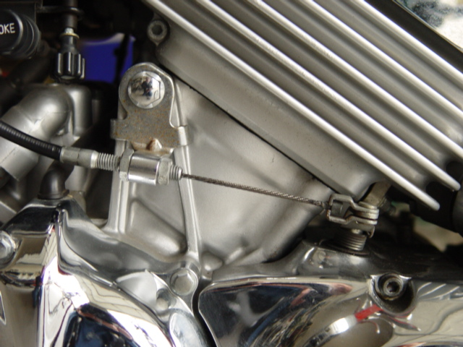
Loosen This
Remove This
The objective is to get this guy loose enough to slide out.

Here’s a close-up of the end of the clutch cable: (It pops out the same way the brake cable is removed from a bicycle hand brake.)
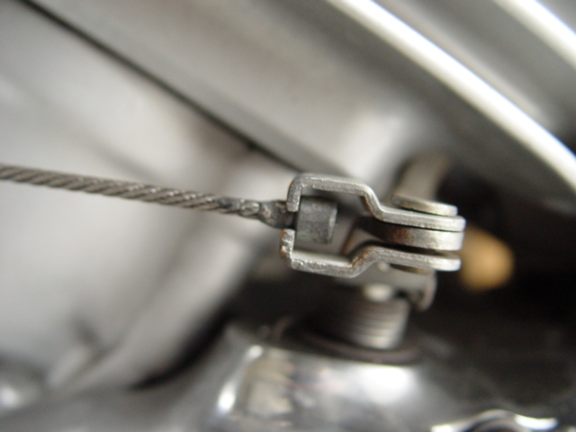
The cable slides out this groove.

Step 2 Remove the Drive sprocket cover (See PDF)
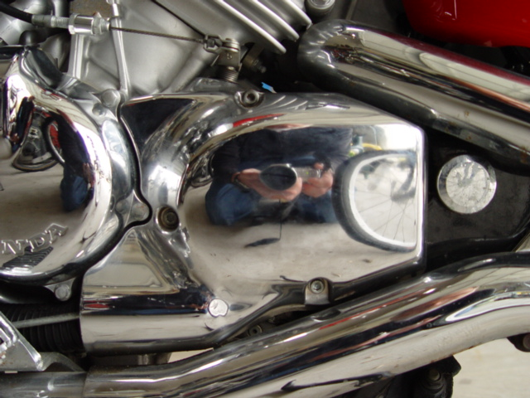
Three bolts.

With the bolts out, it may not want to come loose. I was concerned about forcing it and check with a Honda mechanic. He confirmed that I just needed to wiggle and pry (gently) it off. I did and it worked. I oiled the shafts before I reinstalled it and it slid on nicely.

NOTE: There are no seals or springs or anything loose you need to worry about as you remove this…HOWEVER, I highly recommend that you lay it on a newspaper with the chrome side down. Otherwise, the “clutch lifter piece” that is activated by the “clutch lifter arm” may slide out of place and allow the “clutch lifter arm” to slip down and set you up for a mild coronary until you figure out how to get it reassembled. (If that happens and you can’t figure it out, call me. I speak from experience.)

Step 3 (This is a copy of paragraph three of “The Plan” above.)

All you need to do is loosen the retainer bolt, slip the lever off the “shift linkage” shaft rotate it one or two notches, (depends on how fat your foot is) slide it back into place and retighten the bolt. I don’t remember if you rotate the lever clockwise or counterclockwise, but that will become obvious once your there.

Step 4 Put it back together. (But test it with your boots on first.)

I hope this helps. Have fun…………..biff

P.S. I haven’t proofed this (the sun is out again and my shifter is calling me). If it’s not clear, or you have any questions, email or call me. I’ll review it later. biff@mars-hill.org or 713.828.2455.

